**Exercises:**

1. Write a program that accomplish the following purpose:

a) Call the system call to create the child process and store the value returned from the call.

1. If the returned value is less than zero,

i. Print ‘Unsuccessful Child Process Creation”. ii. Terminate using exit system call

1. If the return value is greater than zero
2. Add a wait system call so that the parent would wait for child process to complete.
3. Make a loop that prints even numbers from 1 - 10 iii. Print “Parent Ends”

c. If the return value is equal to zero

i. Print the parent ID ii. Make a loop that prints odd numbers from 1 - 10 iii. Print “Child Ends”

b) Stop

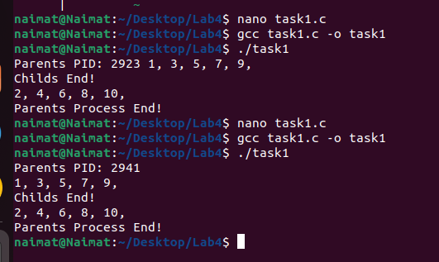

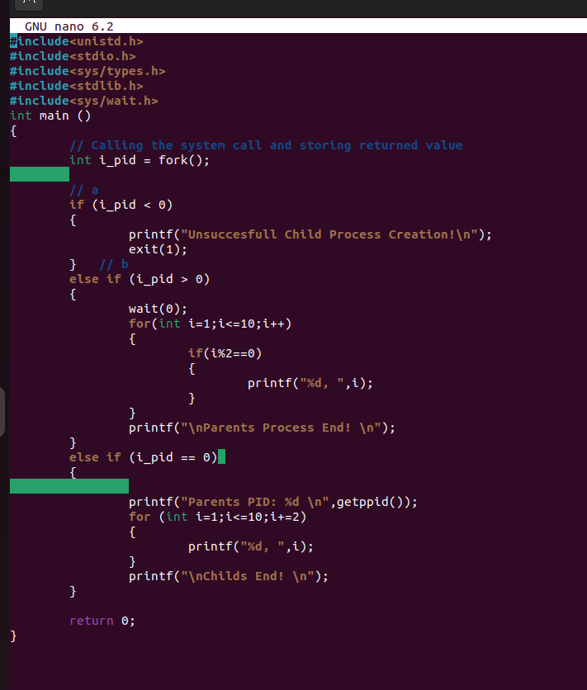

1. Write a Program that Creates n-child process from same parent process using fork() in C

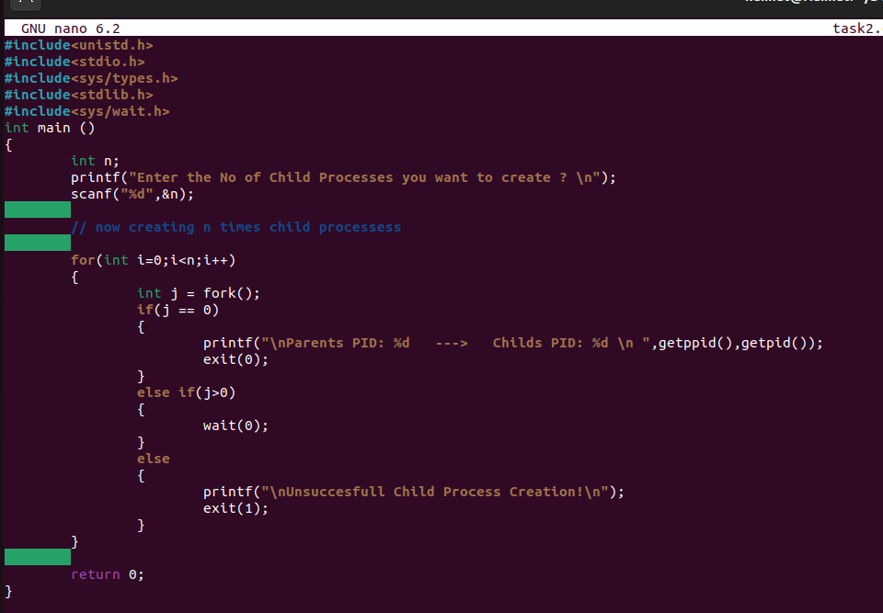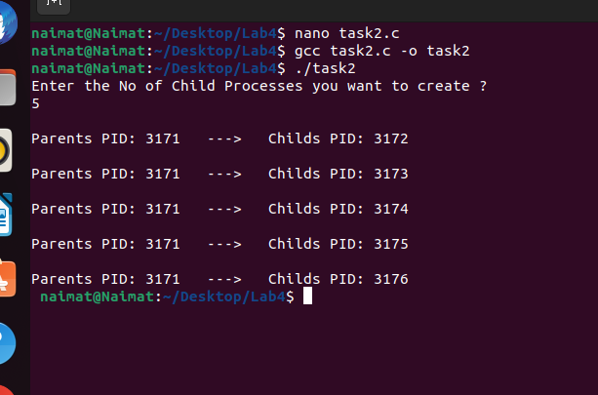

1. Write Program to create four processes (1 parent and 3 children) where they terminates in a sequence as follows:
   * 1. Parent process terminates at last
     2. First child terminates before parent and after second child.
     3. Second child terminates after last and before first child.(d) Third child terminates first.

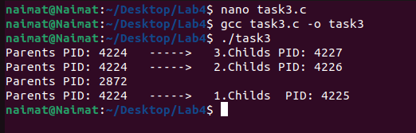

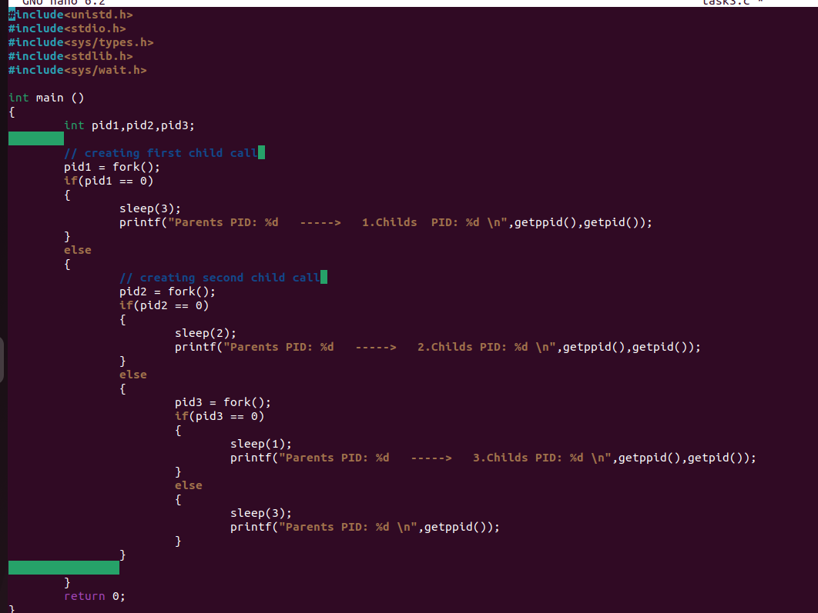

1. Write a program which creates processes 4 processes for parallel programming. Each parent will wait for the termination of its child.

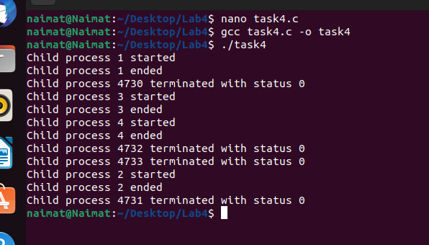

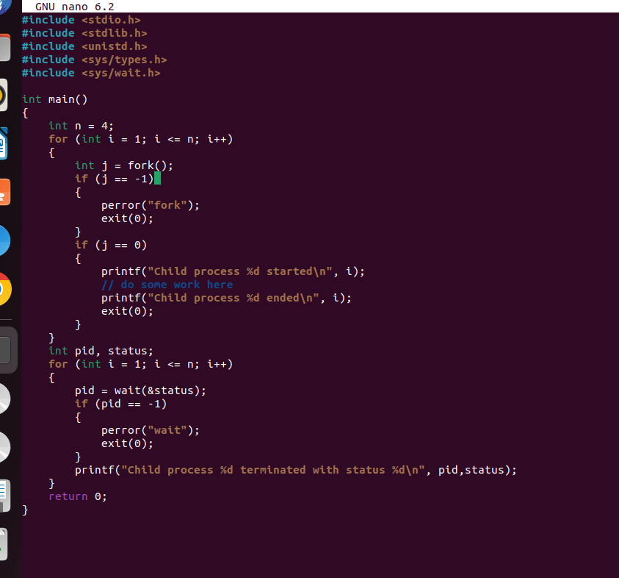

1. Implement the following 9 tree structure. Each node must print its name and PID.

e.g. I am Process A and my PID is 2453

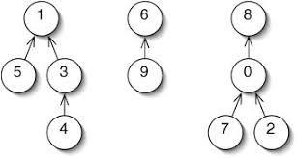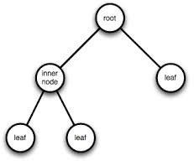

A:

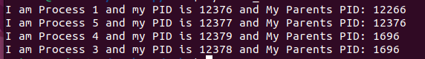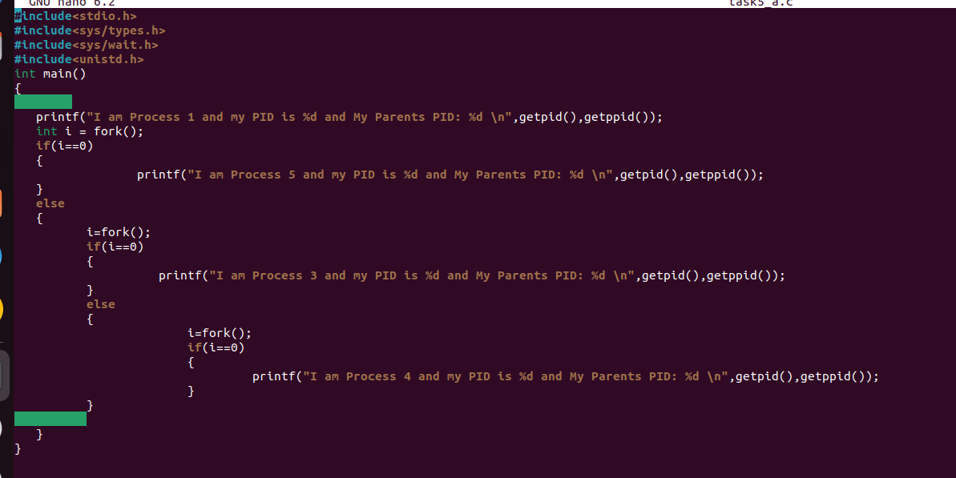

B:

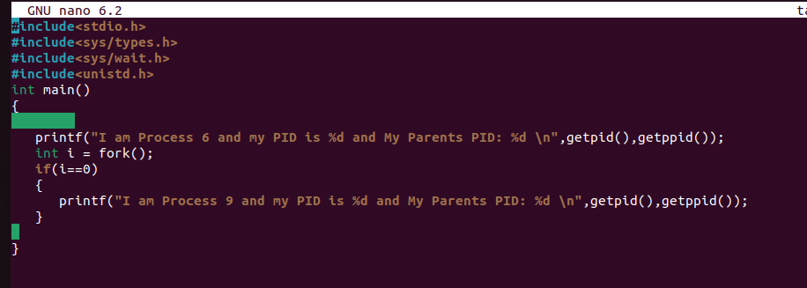

C:

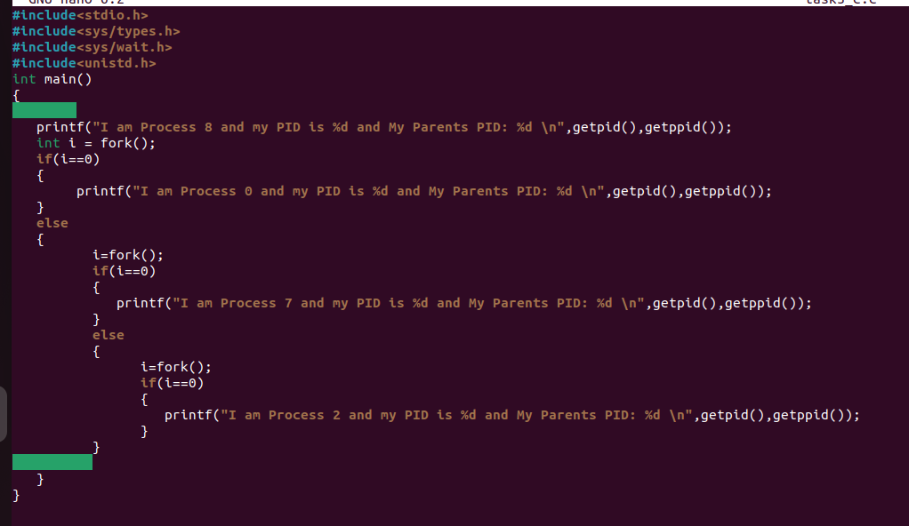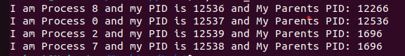

D:

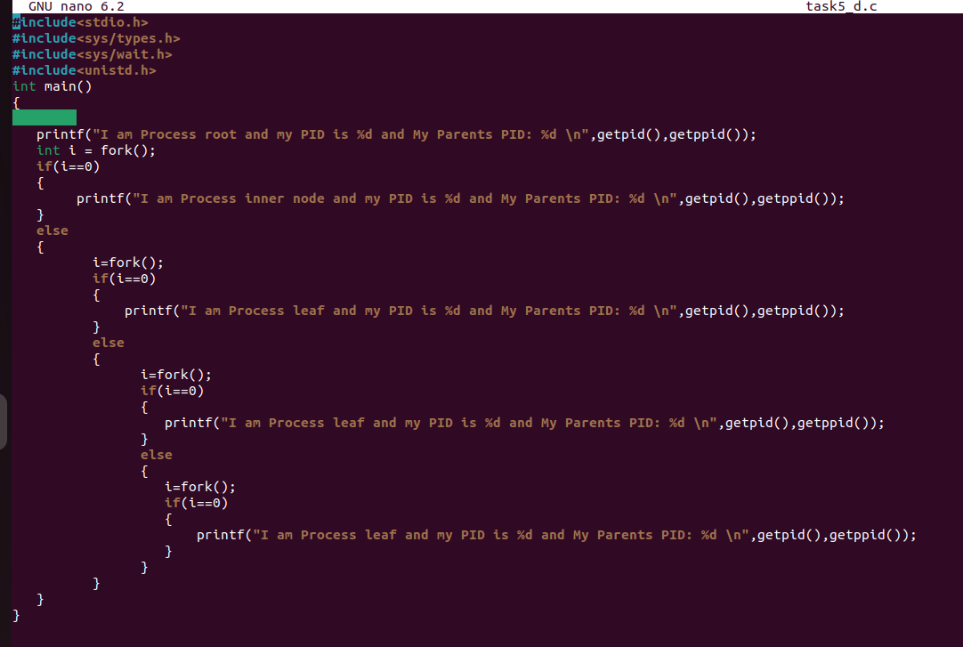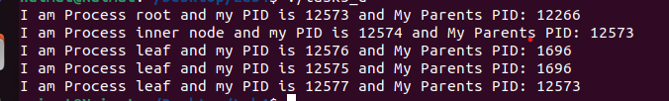

E:

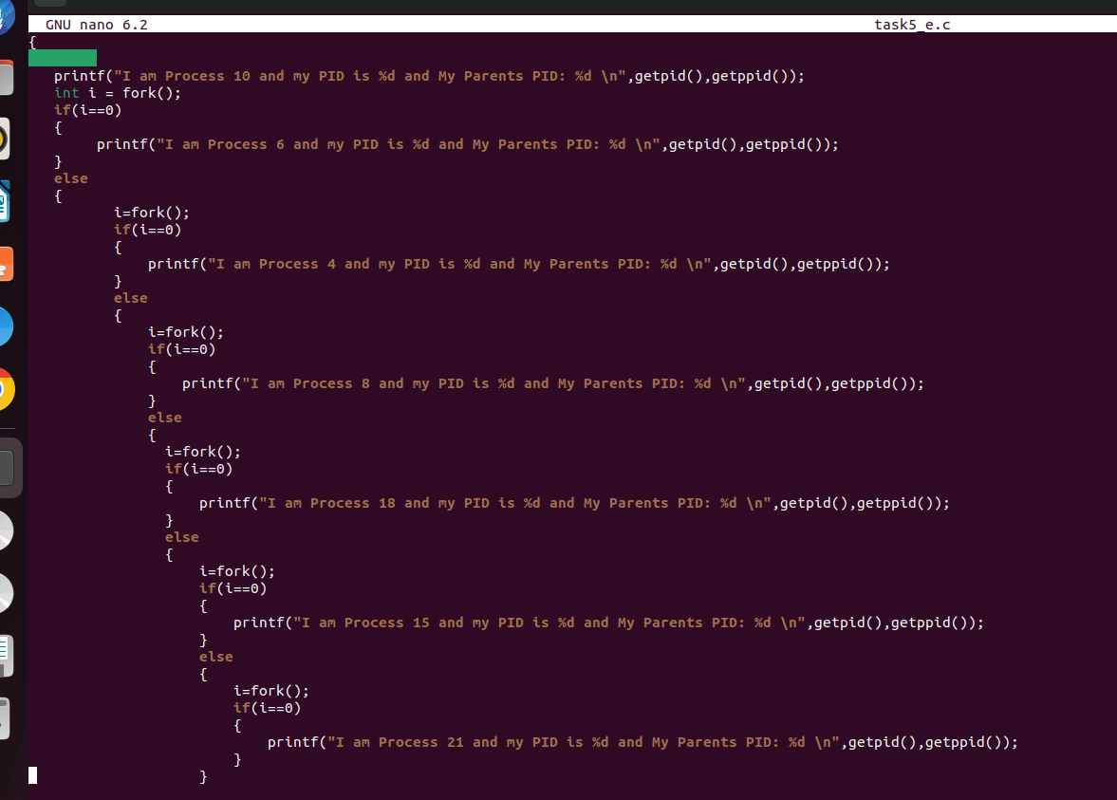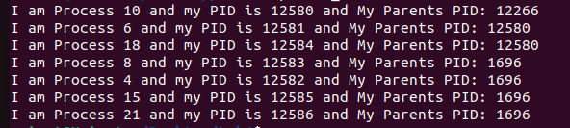

F:

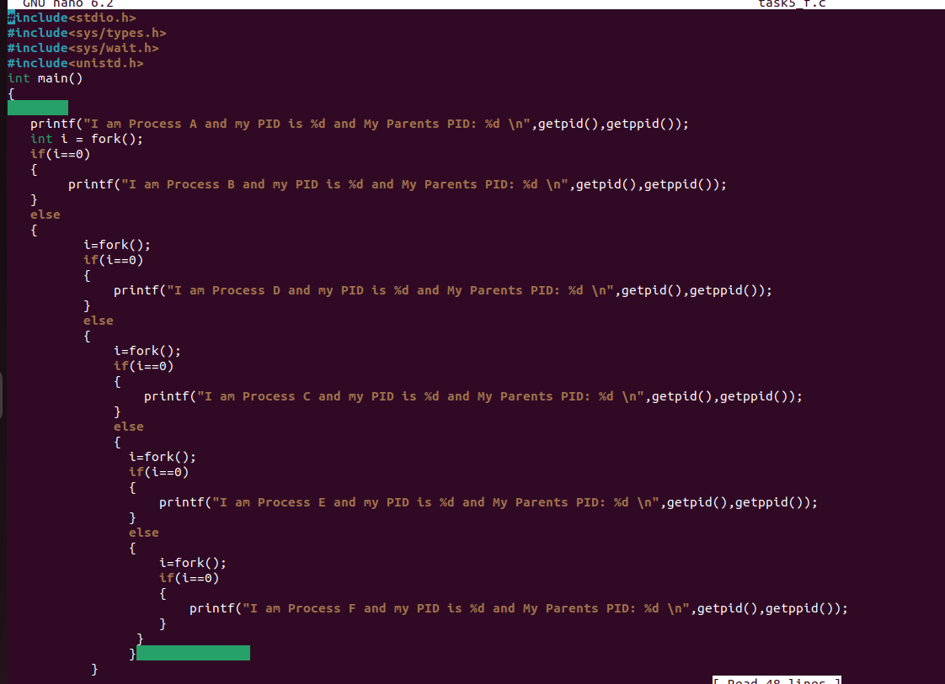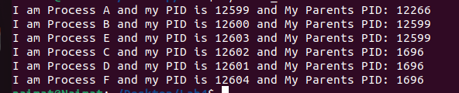

G:

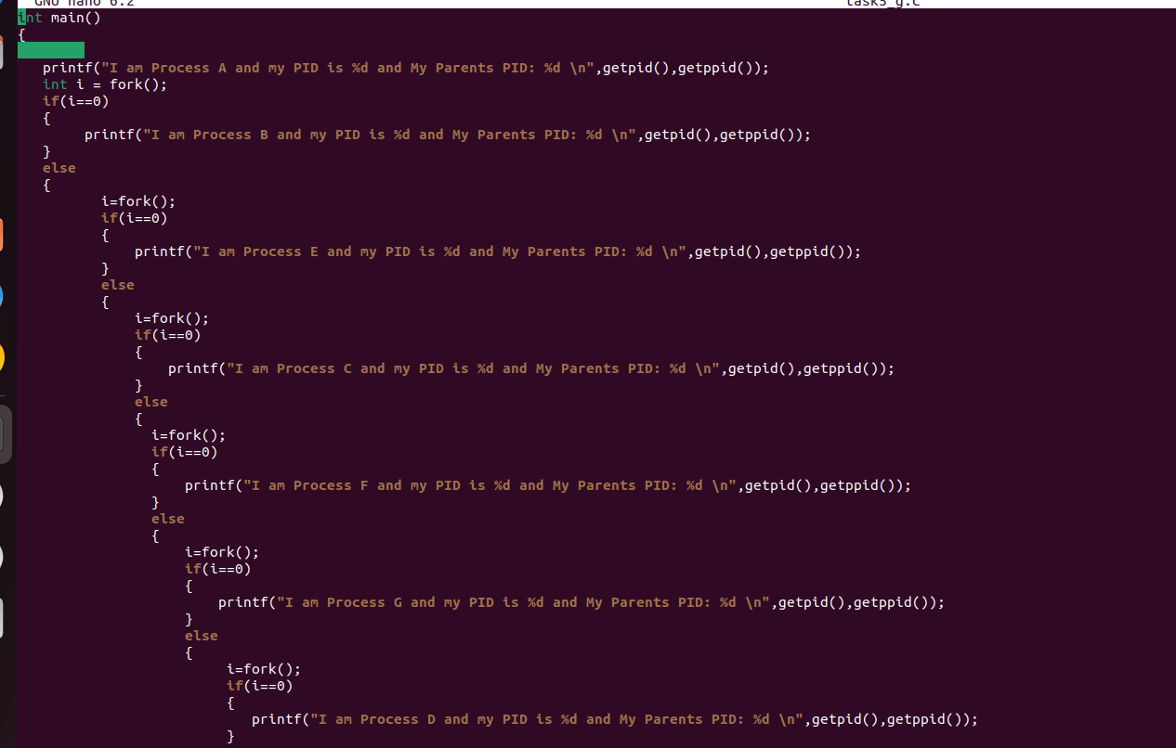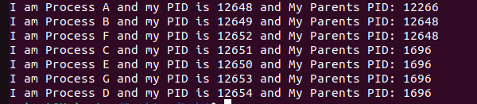

H:

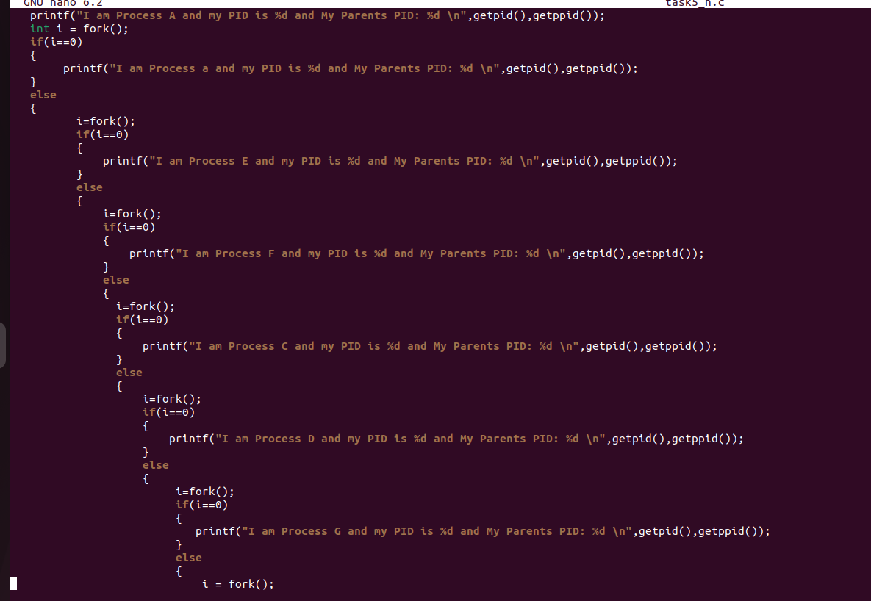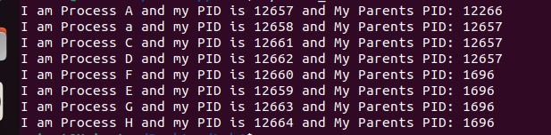

I:

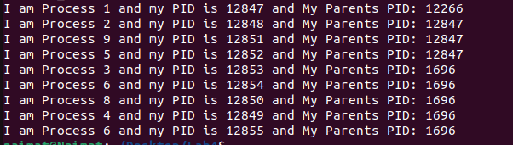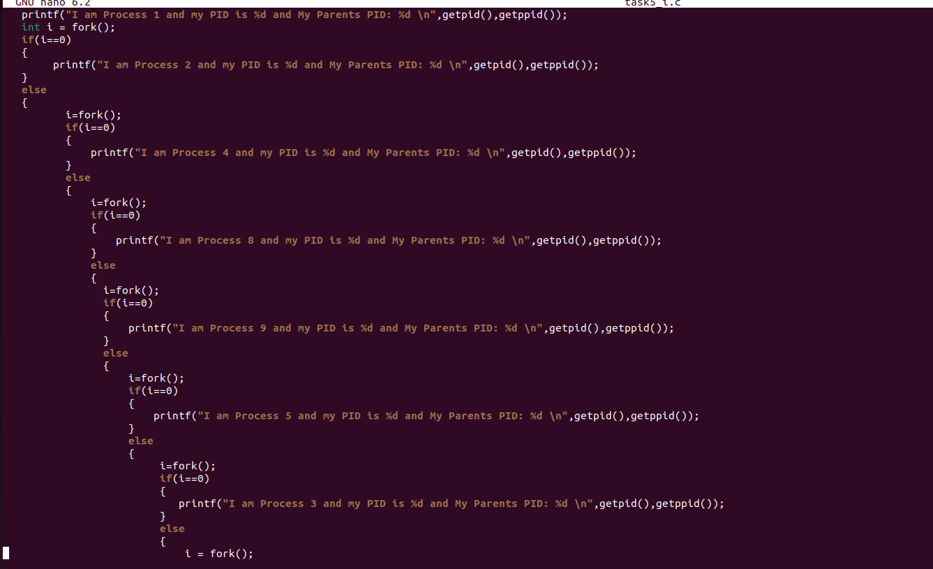

6.